1. **Implement a package LibraryManagement with classes Book and Member. The Book class should have attributes like title, author, and ISBN, while the Member class should store member details. Use this package to create a simple library system.**

**Answer:**

**Book.java**

package LibraryManagement;

public class book {

    String title;

    String author;

    String isbn;

    book(String title, String author, String isbn){

        this.title = title;

        this.author = author;

        this.isbn = isbn;

    }

    public void displayBook(){

        System.out.println("Book title:" +title);

        System.out.println("author name:" +author);

        System.out.println("international standerd book number:" +isbn);

    }

}

**Member.java**

package LibraryManagement;

public class Member {

    String name;

    String memberID;

    public Member(String name, String memberID){

        this.name = name;

        this.memberID = memberID;

    }

    public void displayMember(){

        System.out.println("Member name:" +name);

        System.out.println("Member ID:" +memberID);

    }

}

**LibrarySystem:**

package LibraryManagement;

import java.util.Scanner;

public class LibrarySystem {

    public static void main(String[] args) {

        Scanner sc = new Scanner(System.in);

        System.out.print("Enter Book title:");

        String title = sc.nextLine();

        System.out.print("Enter author name:");

        String author = sc.nextLine();

        System.out.print("Enter isbn:");

        String isbn = sc.nextLine();

        System.out.print("Enter Member name:");

        String name = sc.nextLine();

        System.out.print("Enter Member ID:");

        String memberID = sc.nextLine();

        book b1 = new book(title, author, isbn);

        Member m1 = new Member(name, memberID);

        System.out.println("\n--- Book Details ---");

        b1.displayBook();

        System.out.println("\n--- Member Details ---");

        m1.displayMember();

sc.close();

    }

}

**Output:**

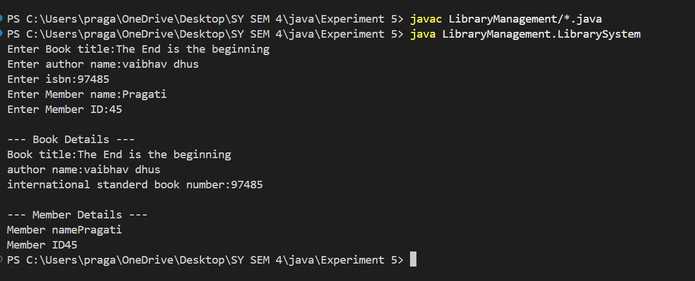

1. **Create a package Ecommerce containing classes Product, Customer, and Order. Implement methods for placing an order, displaying product details, and calculating total order cost. Use this package in another program.**

**Product.java**

package Ecommerce;

public class Product {

private int productId;

private String name;

private double price;

public Product(int productId, String name, double price) {

this.productId = productId;

this.name = name;

this.price = price;

}

public void displayProductDetails() {

System.out.println("Product ID: " + productId);

System.out.println("Name: " + name);

System.out.println("Price: ₹" + price);

}

public double getPrice() {

return price;

}

public String getName() {

return name;

}

}

**Customer.java**

package Ecommerce;

public class Customer {

private int customerId;

private String name;

public Customer(int customerId, String name) {

this.customerId = customerId;

this.name = name;

}

public void displayCustomerDetails() {

System.out.println("Customer ID: " + customerId);

System.out.println("Name: " + name);

}

public String getName() {

return name;

}

}

**Order.java**

package Ecommerce;

public class Order {

private Product product;

private Customer customer;

private int quantity;

public Order(Product product, Customer customer, int quantity) {

this.product = product;

this.customer = customer;

this.quantity = quantity;

}

public void placeOrder() {

System.out.println("Placing Order...");

customer.displayCustomerDetails();

product.displayProductDetails();

System.out.println("Quantity: " + quantity);

System.out.println("Total Cost: ₹" + calculateTotalCost());

}

public double calculateTotalCost() {

return product.getPrice() * quantity;

}

}

**Main.java**

// Main.java

import Ecommerce.Product;

import Ecommerce.Customer;

import Ecommerce.Order;

import java.util.Scanner;

public class Main {

public static void main(String[] args) {

Scanner sc = new Scanner(System.in);

// Product input

System.out.print("Enter Product ID: ");

int pid = sc.nextInt();

sc.nextLine();

System.out.print("Enter Product Name: ");

String pname = sc.nextLine();

System.out.print("Enter Product Price: ");

double price = sc.nextDouble();

// Customer input

System.out.print("Enter Customer ID: ");

int cid = sc.nextInt();

sc.nextLine();

System.out.print("Enter Customer Name: ");

String cname = sc.nextLine();

// Quantity

System.out.print("Enter Quantity: ");

int qty = sc.nextInt();

// Creating objects

Product product = new Product(pid, pname, price);

Customer customer = new Customer(cid, cname);

Order order = new Order(product, customer, qty);

// Place order

order.placeOrder();

}

}

**Output:**

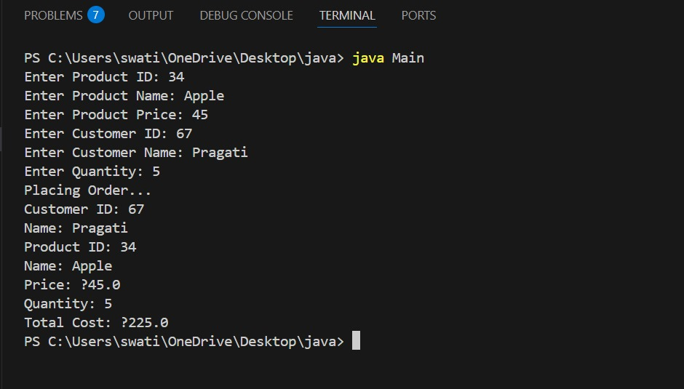

**Q3: Create a package named MathOperations that contains classes for mathematical functions like floor, round, and ceil. Implement a program that uses these functions to perform operations on different numbers. (The Math class in Java contains the methods floor(), ceil(), and round())**

**Answer:**

**Floor.java**

package MathOperations;

public class Floor {

public double apply(double number) {

return Math.floor(number);

}

}

**Ceil.java**

package MathOperations;

public class Ceil {

public double apply(double number) {

return Math.ceil(number);

}

}

**Round.java**

package MathOperations;

public class Round {

public long apply(double number) {

return Math.round(number);

}

}

**Main class:**

import MathOperations.Floor;

import MathOperations.Ceil;

import MathOperations.Round;

public class Main {

public static void main(String[] args) {

double[] numbers = {4.3, 5.8, -2.7, -3.5};

Floor floorOp = new Floor();

Ceil ceilOp = new Ceil();

Round roundOp = new Round();

for (double num : numbers) {

System.out.println("Number: " + num);

System.out.println("Floor: " + floorOp.apply(num));

System.out.println("Ceil: " + ceilOp.apply(num));

System.out.println("Round: " + roundOp.apply(num));

System.out.println("-------------------------");

}

}

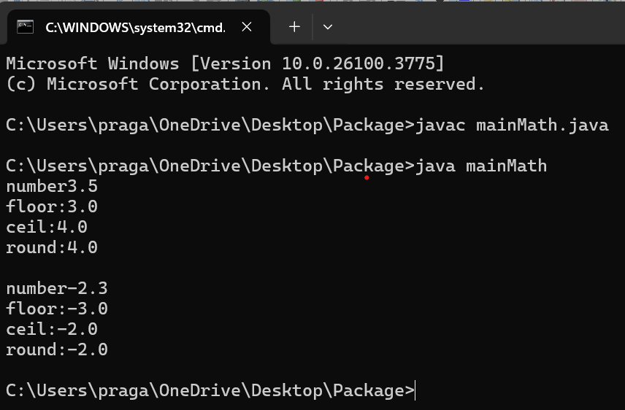

**Q 4: Develop a mathematical package for Statistical operations like factorial, cube. Create a sub package in the math package -convert. In "convert" package provide classes to convert decimal to octal, binary, hex and vice-versa. Develop application program to use this package .**

**Package:**

package mathpackage;

class MathOperations {

public static int factorial(int n) {

int fact = 1;

for(int i = 1; i <= n; i++) {

fact *= i;

}

return fact;

}

public static int cube(int n) {

return n * n * n;

}

}

**mathpackage.convert.DecimalConverter**

package mathpackage.convert;

public class DecimalConverter {

public static String toBinary(int num) {

return Integer.toBinaryString(num);

}

public static String toOctal(int num) {

return Integer.toOctalString(num);

}

public static String toHex(int num) {

return Integer.toHexString(num).toUpperCase();

}

}

**mathpackage.convert.BaseConverter**

package mathpackage.convert;

public class BaseConverter {

public static int binaryToDecimal(String binary) {

return Integer.parseInt(binary, 2);

}

public static int octalToDecimal(String octal) {

return Integer.parseInt(octal, 8);

}

public static int hexToDecimal(String hex) {

return Integer.parseInt(hex, 16);

}

**}**

**Main App**

import mathpackage.MathOperations;

import mathpackage.convert.DecimalConverter;

import mathpackage.convert.BaseConverter;

public class MainApp {

public static void main(String[] args) {

int num = 5;

System.out.println("Factorial of " + num + ": " + MathOperations.factorial(num));

System.out.println("Cube of " + num + ": " + MathOperations.cube(num));

System.out.println("Binary of " + num + ": " + DecimalConverter.toBinary(num));

System.out.println("Octal of " + num + ": " + DecimalConverter.toOctal(num));

System.out.println("Hexadecimal of " + num + ": " + DecimalConverter.toHex(num));

System.out.println("Binary '101' to Decimal: " + BaseConverter.binaryToDecimal("101"));

System.out.println("Octal '7' to Decimal: " + BaseConverter.octalToDecimal("7"));

System.out.println("Hex 'A' to Decimal: " + BaseConverter.hexToDecimal("A"));

}

}

Output:

Enter a number for factorial and cube: 5

Factorial: 120

Cube: 125

Decimal to Binary: 101

Decimal to Octal: 5

Decimal to Hexadecimal: 5

Enter a binary number to convert to decimal: 110

Binary to Decimal: 6

Enter an octal number to convert to decimal: 10

Octal to Decimal: 8

Enter a hexadecimal number to convert to decimal: A

Hex to Decimal: 10

Q5. . **Write a Java program to perform employee payroll processing using packages. In the java file, Emp.java creates a package employee and creates a class Emp. Declare the variables name, empid, category, bpay, hra, da, npay, pf, grosspay, incometax, and allowance. Take da 5%, hra 9%, pf 11% and allowance 10% of bpay. Calculate the values in methods. Create another java file Emppay.java. Create an object e to call the methods to perform and print values**

Answer:

Package:

package employee;

public class Emp {

String name;

int empid;

String category;

double bpay, hra, da, pf, allowance;

double grosspay, npay, incometax;

public void getDetails(String name, int empid, String category, double bpay) {

this.name = name;

this.empid = empid;

this.category = category;

this.bpay = bpay;

}

public void calculate() {

da = bpay * 0.05;

hra = bpay * 0.09;

pf = bpay * 0.11;

allowance = bpay * 0.10;

grosspay = bpay + da + hra + allowance;

incometax = grosspay * 0.10; // Assuming 10% IT

npay = grosspay - (pf + incometax);

}

public void display() {

System.out.println("Employee ID: " + empid);

System.out.println("Name: " + name);

System.out.println("Category: " + category);

System.out.println("Basic Pay: " + bpay);

System.out.println("DA (5%): " + da);

System.out.println("HRA (9%): " + hra);

System.out.println("PF (11%): " + pf);

System.out.println("Allowance (10%): " + allowance);

System.out.println("Gross Pay: " + grosspay);

System.out.println("Income Tax (10%): " + incometax);

System.out.println("Net Pay: " + npay);

}

}

**Main class:**

import employee.Emp;

import java.util.Scanner;

public class Emppay1 {

public static void main(String[] args) {

Scanner sc = new Scanner(System.in);

System.out.print("Enter employee name: ");

String name = sc.nextLine();

System.out.print("Enter employee ID: ");

int empid = sc.nextInt();

sc.nextLine(); // consume leftover newline

System.out.print("Enter category: ");

String category = sc.nextLine();

System.out.print("Enter basic pay: ");

double bpay = sc.nextDouble();

Emp e = new Emp();

e.getDetails(name, empid, category, bpay);

e.calculate();

System.out.println("\n--- Employee Payroll Details ---");

e.display();

}

}

**Outputs :**

